Taping Procedure
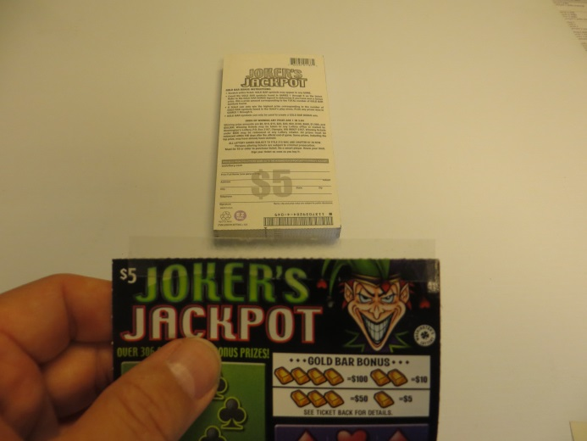
Figure 1
- Take a tape strip from the sheet and carefully position it to the first ticket of the second pack so the perforated tape is in line with the junction of the two tickets. Take care that the tape does not hang off of the edge of the tickets (see figure 1)

. 

Figure 2

- Lay ticket packs up against each other on a flat surface so that the last ticket of one pack is against the first ticket of another pack. Leaving no space between the tickets, align the edges of the packs carefully and do not overlap them(see figure 2)
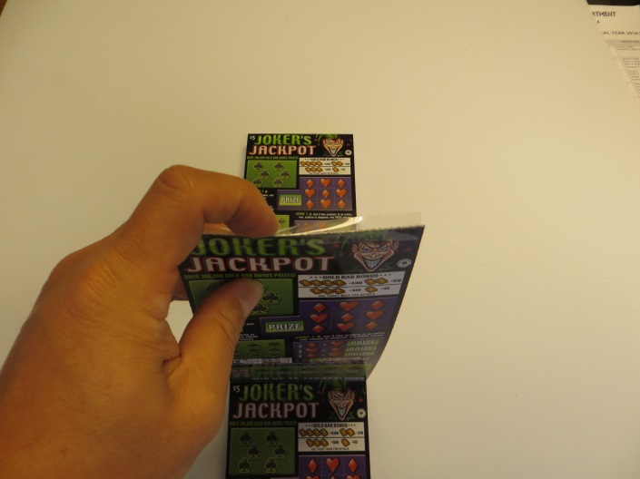

Figure 3

- Fold one of the packs over the other, bending the tape at the perforated tape. Packs should stack neatly, one on top of another (see Figure 3)

Take care to avoid these problems:
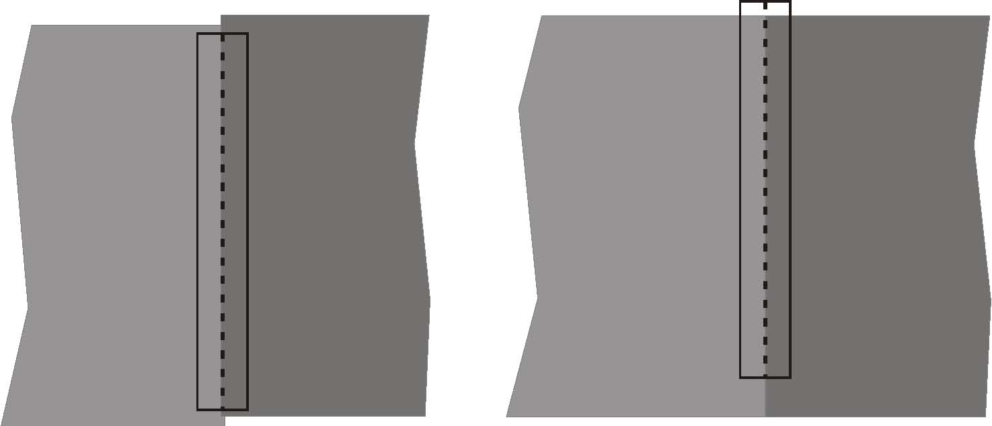
Edges of packs misaligned Tape hanging off of edge of tickets
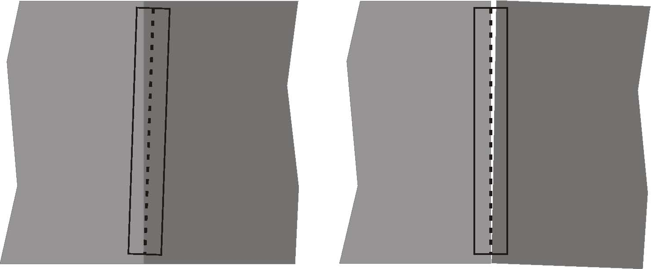
Tape not aligned with ticket junction Tickets not tightly butted up against each other

